**Software Engineering Tools Lab**

**Assignment No-9**

**Module 5- Software testing using tools**

**PRN: 2020BTECS00079**

**Name: Saurabh Khadsang**

Q 1. What are the prerequisites for installing the Selenium.

1. Java Development Kit (JDK) - Selenium is a Java-based tool, so you need to have JDK installed on your system.
2. Web Browser - Selenium supports different web browsers such as Chrome, Firefox, Safari, etc. You need to have at least one of these browsers installed on your machine.
3. Selenium WebDriver - This is the core component of the Selenium suite. You can download WebDriver from the official Selenium website.

Q 2. Install Selenium tool on your machine (Provide screen shots for successful

installation and login)

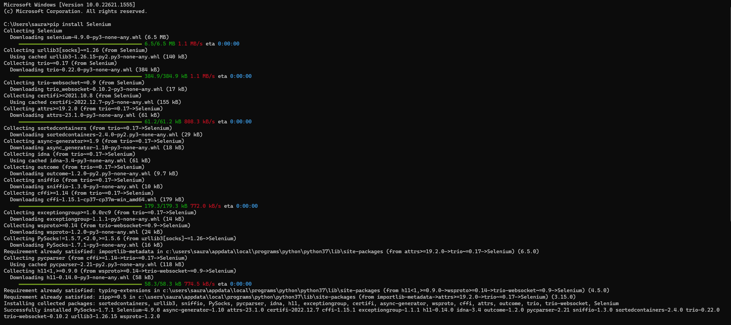

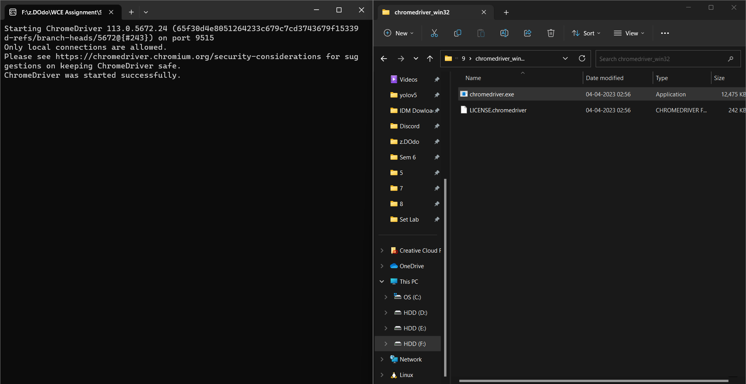

Q 3. Using Selenium tool create multiple test cases (at least 10) on any application/project that you have implemented.

Perform below tasks

1. Create New test project as SETProject

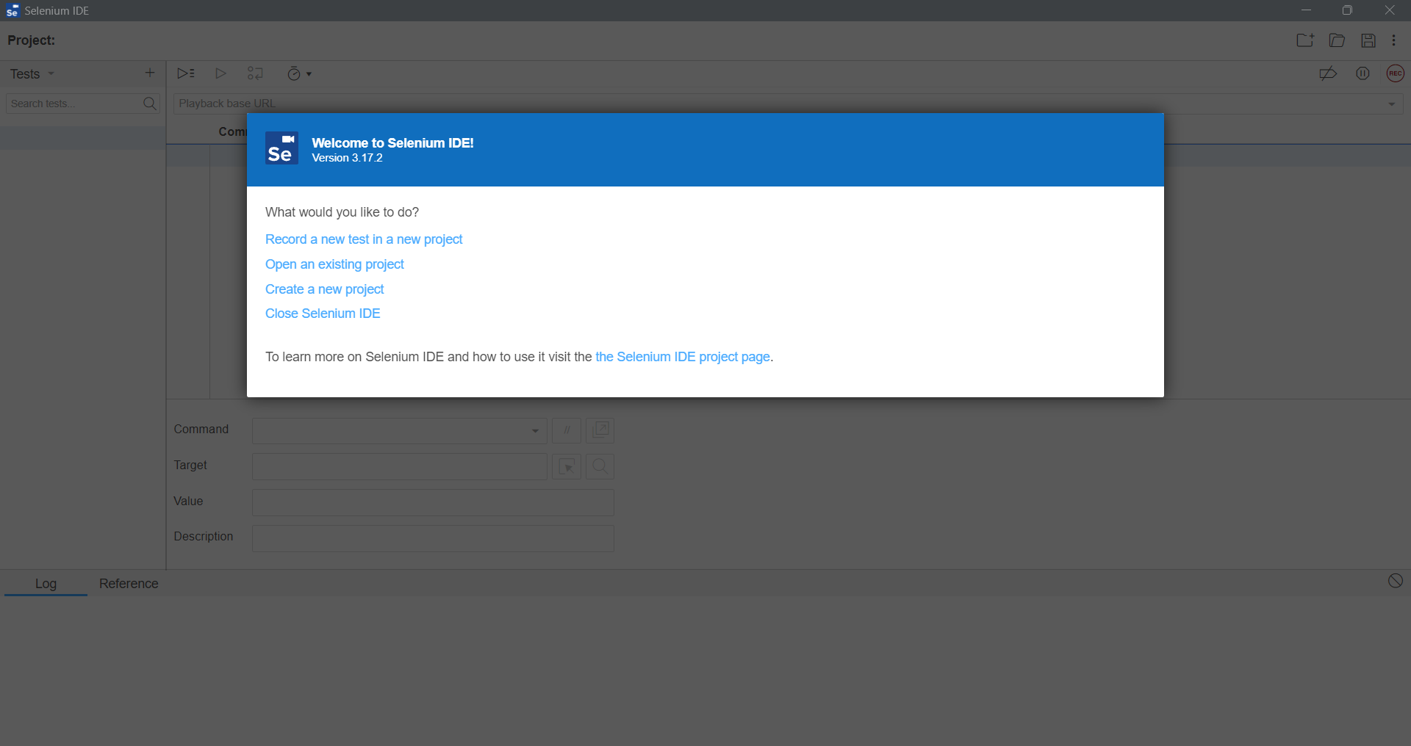

b. Create a test plan as SETProjectTestPlan

c. Create a build as SETProjectBuild

d. Create test suite as Test Suite 1 under SETProject

Create Test cases in Selenium Too

